VIETNAM NATIONAL UNIVERSITY – HCMC  UNIVERSITY OF  INFORMATION TECHNOLOGY | SOCIALIST REPUBLIC OF VIETNAM  Independent – Freedom – Happiness
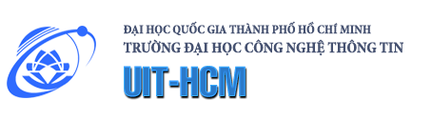

REDHAT SPONSORSHIP’S APPLICATION
FOR UIT’S PHD CANDIDATE
No. | Content | Description
1. | Name of the Thesis
2. | Name of the Student
3. | Name of the Advisor(s)
4. | Expected duration of the Thesis (from when to when)

Description of the PhD Thesis:

Date: September 28, 2015
Name:
Signature:

